UNITED STATES
SECURITIES AND EXCHANGE COMMISSION
Washington, D.C. 20549

FORM 8-K

CURRENT REPORT
Pursuant to Section 13 or 15(d) of the Securities Exchange Act of 1934
Date of Report (Date of earliest event reported): August 4, 2026

Palvella Therapeutics, Inc.
(Exact name of registrant as specified in its charter)

Nevada |  |  | 001-37471 | 30-0784346
(State or other jurisdiction  of incorporation) |  |  | (Commission File Number) | (IRS Employer  Identification No.)
353 W. Lancaster Ave, Suite 200
Wayne, Pennsylvania |  |  |  | 19087
(Address of principal executive offices) |  |  |  | (Zip Code)

Registrant’s telephone number, including area code: (484) 253-1461

(Former name or former address, if changed since last report)

Check the appropriate box below if the Form 8-K filing is intended to simultaneously satisfy the filing obligation of the registrant under any of the following provisions:
☐Written communications pursuant to Rule 425 under the Securities Act (17 CFR 230.425)
☐Soliciting material pursuant to Rule 14a-12 under the Exchange Act (17 CFR 240.14a-12)
☐Pre-commencement communications pursuant to Rule 14d-2(b) under the Exchange Act (17 CFR 240.14d-2(b))
☐Pre-commencement communications pursuant to Rule 13e-4(c) under the Exchange Act (17 CFR 240.13e-4(c))
Securities registered pursuant to Section 12(b) of the Act:

Title of each class |  | Trading  Symbol(s) |  | Name of each exchange on which registered
Common Stock, $0.001 par value per share |  | PVLA |  | The Nasdaq Global Market
Indicate by check mark whether the registrant is an emerging growth company as defined in Rule 405 of the Securities Act of 1933 (§ 230.405 of this chapter) or Rule 12b-2 of the Securities Exchange Act of 1934 (§ 240.12b-2 of this chapter).
Emerging growth company ☐
If an emerging growth company, indicate by check mark if the registrant has elected not to use the extended transition period for complying with any new or revised financial accounting standards provided pursuant to Section 13(a) of the Exchange Act. ☐

Item 2.02 Results of Operations and Financial Condition.
On August 4, 2026, Palvella Therapeutics, Inc. (the “Company”) announced its financial results for the quarter ended June 30, 2026. A copy of the press release is being furnished as Exhibit 99.1 to this Current Report on Form 8-K and is incorporated herein by reference.
The information furnished pursuant to this Item 2.02, including Exhibit 99.1 attached hereto, is intended to be furnished and shall not be deemed “filed” for purposes of Section 18 of the Securities Exchange Act of 1934, as amended (the “Exchange Act”), or otherwise subject to the liabilities of that section, nor shall it be deemed incorporated by reference in any filing under the Securities Act of 1933, as amended (the “Securities Act”), or the Exchange Act, except as expressly set forth by specific reference in such filing.

Item 7.01 Regulation FD Disclosure.
On August 4, 2026, the Company will hold its earnings call and use a slide presentation in conjunction with the earnings call. A copy of the presentation is furnished herewith as Exhibit 99.2, and incorporated herein by reference.
The information furnished pursuant to Item 7.01, including Exhibit 99.2, shall not be deemed “filed” for purposes of Section 18 of the Exchange Act or otherwise subject to the liabilities of that section, and shall not be deemed to be incorporated by reference in any filing under the Securities Act or the Exchange Act, except as expressly set forth by specific reference in such filing.

Item 9.01 Financial Statements and Exhibits.

(d) Exhibits
Exhibit No. |  | Description
99.1 |  | Press Release of Palvella Therapeutics, Inc., dated August 4, 2026*
99.2 |  | Earnings Call Presentation of Palvella Therapeutics, Inc., dated August 4, 2026*
104 |  | Cover Page Interactive Data File (embedded within the Inline XBRL document)
* Furnished herewith

SIGNATURES
Pursuant to the requirements of the Securities Exchange Act of 1934, the registrant has duly caused this report to be signed on its behalf by the undersigned hereunto duly authorized.
 |  |  | Palvella Therapeutics, Inc.
Date: | August 4, 2026 | By: | /s/ Matthew Korenberg
 |  |  | Matthew Korenberg
 |  |  | Chief Financial Officer



Palvella Therapeutics Reports Second Quarter 2026 Financial Results and Provides Corporate Update

First module of the rolling NDA for QTORIN rapamycin for microcystic lymphatic malformations submitted to FDA, with completion of the NDA submission on track for the second half of 2026

Preparing for a planned standalone U.S. commercial launch of QTORIN rapamycin for microcystic lymphatic malformations in the first half of 2027, if approved

Initiation of Phase 3 trial of QTORIN rapamycin for the treatment of cutaneous venous malformations planned for the fourth quarter of 2026

Initiation of Phase 2 trial of QTORIN pitavastatin for the treatment of disseminated superficial actinic porokeratosis planned for the second half of 2026

Topline results from the Phase 2 LOTU trial of QTORIN rapamycin for clinically significant angiokeratomas expected in the second half of 2027

Cash, cash equivalents and short-term investments of $250.6 million as of June 30, 2026

Company to host conference call at 8:30 a.m. ET today

WAYNE, Pa., August 4, 2026 (GLOBE NEWSWIRE) -- Palvella Therapeutics, Inc. (Palvella or “the Company”) (Nasdaq: PVLA), a clinical-stage biopharmaceutical company focused on developing and commercializing novel therapies for serious, rare skin diseases and vascular malformations for which there are no U.S. Food and Drug Administration (FDA)-approved therapies, today reported financial results for the second quarter ending June 30, 2026 and provided a corporate update.

“We made significant progress during the second quarter, completing our pre-NDA meeting with FDA and initiating the rolling NDA submission for QTORIN rapamycin in microcystic lymphatic malformations,” said Wes Kaupinen, Founder and Chief Executive Officer of Palvella. “We are working closely with FDA under the program’s Breakthrough Therapy and Fast Track designations to expedite development and review, with the objective of potentially introducing the first approved therapy to pediatric and adult patients living with this serious, lifelong disease. Completion of the NDA submission remains on track for the second half of 2026, and we are preparing for a planned standalone commercial launch in the first half of 2027, if approved. We have recruited commercial and medical affairs leaders with deep experience in rare disease and dermatology who are now in the field executing key pre-launch activities, while we continue to advance our other rare disease programs and pursue additional opportunities across the QTORIN platform.”

Recent Research and Development Highlights

QTORIN rapamycin for microcystic lymphatic malformations (microcystic LMs)

•
James Treat, M.D., of Children’s Hospital of Philadelphia presented additional Phase 3 SELVA data during a late-breaking session at the International Society for the Study of Vascular Anomalies World Congress (ISSVA), including a statistically significant improvement in the 6–11-year-old cohort and other supportive findings showing improvements in clinical signs and patient-reported outcomes with QTORIN rapamycin.
•
Completed an in-person pre-New Drug Application (NDA) meeting with FDA which addressed nonclinical, clinical pharmacology, clinical information, and the planned evidence package for the NDA.
•
Following the pre-NDA meeting, FDA granted Palvella’s request for Rolling Review of the QTORIN rapamycin NDA for microcystic LMs, allowing the Agency to begin reviewing completed portions of the application before submission of the full NDA.
•
Submitted the first module of its rolling NDA to the FDA seeking approval of QTORIN rapamycin for the treatment of microcystic LMs.
•
The Company remains on track to complete the NDA submission in the second half of 2026.

QTORIN rapamycin for cutaneous venous malformations (cutaneous VMs)

•
In May 2026, at the 83rd Annual Meeting of the Society for Investigative Dermatology (“SID”), Palvella presented new data from our Phase 2 TOIVA trial of QTORIN rapamycin for the treatment of cutaneous VMs highlighting that 100% of patients with bleeding at baseline demonstrated improvement on the Cutaneous Venous Malformations Investigator Global Assessment Bleeding scale at Week 12.
•
Dr. Treat presented additional Phase 2 TOIVA data, including 24-week results, at ISSVA demonstrating statistically significant improvements in both cVM-MCSS Height/Engorgement and cVM-MCSS Appearance at all measured time points, with increasing clinical response observed with longer duration of QTORIN rapamycin therapy.
•
Phase 3 trial initiation remains on track for the fourth quarter of 2026 following completion of the planned End-of-Phase 2 meeting.

QTORIN rapamycin for clinically significant angiokeratomas

•
Dosed the first patients in LOTU, a multicenter Phase 2 trial evaluating Fast Track-designated QTORIN rapamycin for clinically significant angiokeratomas, a rare, chronic and debilitating isolated lymphatic malformation affecting an estimated more than 50,000 diagnosed patients in the U.S. and for which there are no FDA-approved therapies.
•
Topline results from LOTU are expected in the second half of 2027.

QTORIN pitavastatin for disseminated superficial actinic porokeratosis (DSAP)

•
Palvella's second product candidate, QTORIN pitavastatin, is for the treatment of disseminated superficial actinic porokeratosis, a premalignant genetic skin disease that presents as persistent, often extensive lesions that enlarge and increase in size, number, and extent over time, causing chronic loss of skin integrity which can severely impact quality-of-life; no FDA-approved therapies currently exist for the estimated more than 50,000 diagnosed patients in the U.S.
•
Strengthened the intellectual property position supporting QTORIN pitavastatin through the issuance of U.S. Patent No. 12,636,273, exclusively licensed from Yale University and building on pioneering work by Keith Choate, M.D., Ph.D. The issued claims cover the topical administration of HMG-CoA reductase inhibitors, including pitavastatin, for the treatment of porokeratosis, including DSAP, and provide protection into 2043.
•
Phase 2 trial initiation expected in the second half of 2026.
QTORIN rapamycin and QTORIN platform expansion

•
Palvella plans to announce the fourth target clinical indication for QTORIN rapamycin in the second half of 2026. The expansion of QTORIN rapamycin into additional indications is supported by a growing body of published literature highlighting the broad potential of rapamycin in several difficult-to-treat, mTOR-driven skin diseases while advocating for targeted, topical approaches suited to improve tolerability and safety.
•
Palvella plans to announce the third product candidate from the QTORIN platform in a serious, rare disease with no FDA-approved therapies in the second half of 2026.

Recent Corporate Highlights

•
Appointed accomplished rare disease biotech executive and commercial leader Matt Pauls, J.D., M.B.A., to the Board of Directors, further strengthening the Board with extensive experience in rare disease drug development, commercialization, and corporate strategy from executive and Board roles at Savara Inc., Soleno Therapeutics, Strongbridge Biopharma and Insmed Incorporated.
•
Awarded “Healthcare & Life Sciences Company of the Year” at the 2026 Philadelphia Alliance for Capital and Technology Ecosystem Awards, recognizing Palvella's leadership in advancing innovative therapies for rare diseases and its contributions to the region's life sciences ecosystem.
•
Completed the uplisting to the Nasdaq Global Market, providing increased visibility within the investment community and reflecting the Company’s continued growth and achievement of key corporate milestones.

Second Quarter 2026 Financial Results

•
Cash, cash equivalents, and short-term investments as of June 30, 2026 were $250.6 million.
•
Research and development expenses for the three months ended June 30, 2026 were $12.5 million, as compared to $5.1 million for the three months ended June 30, 2025. The increase was primarily due to increased spending for manufacturing activities, clinical development of QTORIN rapamycin for the treatment of angiokeratomas, costs associated with the submission of the first module of the rolling NDA, and costs resulting from increased headcount and consulting services in 2026.
•
General and administrative expenses for the three months ended June 30, 2026 were $8.9 million, as compared to $4.1 million for the three months ended June 30, 2025. The increase was primarily due to increased headcount in 2026, as well as increased professional services related to operating as a publicly-traded company.
•
Net loss was $21.9 million, or $1.52 per basic and diluted share, for the three months ended June 30, 2026, as compared to net loss of $9.5 million, or $0.86 per basic and diluted share, for the three months ended June 30, 2025.
•
Weighted average shares outstanding for calculation of EPS in Q2 2026 and YTD 2026 were 14,356,219 and 13,724,256 respectively. Shares outstanding were 15,802,768 as of July 31, 2026, including 14,408,007 shares of common stock and 1,394,761 common share equivalents assuming conversion of outstanding pre-funded warrants.

Conference Call Details

Palvella will host a conference call and live audiovisual webcast to discuss the Company's second quarter 2026 financial results and provide a corporate update at 8:30 a.m. ET today. To access the live webcast, including presentation slides, please click here or visit the “Events & Presentations” section of Palvella’s website. To access the conference call by phone, register using this link, and you will be provided with dial-in details. A replay of the webcast will be available approximately two hours after the conclusion of the call and will remain archived for 90 days under the “Events & Presentations” section of the Company's website at www.palvellatx.com.

About Palvella Therapeutics

Founded and led by rare disease biotech veterans, Palvella Therapeutics, Inc. (Nasdaq: PVLA) is a clinical-stage biopharmaceutical company focused on developing and commercializing novel therapies to treat patients living with serious, rare skin diseases and vascular malformations for which there are no FDA-approved therapies. Palvella is developing a broad pipeline of product candidates based on its patented QTORIN platform, with an initial focus on serious, rare skin diseases and vascular malformations, many of which are lifelong in nature. Palvella’s lead product candidate, QTORIN 3.9% rapamycin anhydrous gel (QTORIN rapamycin), is currently being developed for the treatment of microcystic lymphatic malformations, cutaneous venous malformations, and clinically significant angiokeratomas. Palvella’s second product candidate, QTORIN pitavastatin, is currently being developed for the treatment of disseminated superficial

actinic porokeratosis. For more information, please visit www.palvellatx.com or follow Palvella on LinkedIn or X (formerly known as Twitter).

QTORIN rapamycin and QTORIN pitavastatin are for investigational use only and neither has been approved by the FDA or by any other regulatory agency for any indication.

Forward-Looking Statements

This press release contains forward-looking statements (including within the meaning of Section 21E of the Securities Exchange Act of 1934, as amended, and Section 27A of the Securities Act of 1933, as amended (Securities Act)). These statements may discuss goals, intentions, and expectations as to future plans, trends, events, results of operations or financial condition, or otherwise, based on current beliefs of the management of Palvella, as well as assumptions made by, and information currently available to, the management of Palvella. Forward-looking statements generally include statements that are predictive in nature and depend upon or refer to future events or conditions, and include words such as “may,” “will,” “should,” “would,” “expect,” “anticipate,” “plan,” “likely,” “believe,” “estimate,” “project,” “intend,” and other similar expressions or the negative or plural of these words, or other similar expressions that are predictions or indicate future events or prospects, although not all forward-looking statements contain these words. Statements that are not historical facts are forward-looking statements. Forward-looking statements include, but are not limited to, statements regarding the expected timing of the presentation of data from clinical trials, Palvella’s clinical development plans and related anticipated development milestones and anticipated timing of regulatory submissions, Palvella’s plans with respect to the timing of, and anticipated FDA review process for, the NDA for QTORIN rapamycin, Palvella’s plans to pursue Breakthrough Therapy Designation, Palvella’s plans to meet with regulatory authorities, Palvella’s expectations regarding the benefits of orphan drug designation and potential benefit of orphan drug exclusivity for QTORIN rapamycin for the treatment of microcystic lymphatic malformations, Palvella’s cash, financial resources and expected runway, Palvella’s expectations regarding its programs, including QTORIN rapamycin and QTORIN pitavastatin, and its research-stage opportunities, including its expected therapeutic potential and market opportunity. Forward-looking statements are based on current beliefs and assumptions that are subject to risks and uncertainties and are not guarantees of future performance. Actual results could differ materially from those contained in any forward-looking statement as a result of various factors, including, without limitation: the ability to raise additional capital to finance operations; the ability to advance product candidates through preclinical and clinical development; the ability to make regulatory submissions on anticipated timelines; the ability to obtain regulatory approval for, and ultimately commercialize, Palvella’s product candidates, including QTORIN rapamycin and QTORIN pitavastatin; the outcome of early clinical trials for Palvella’s product candidates, including the ability of those trials to satisfy relevant governmental or regulatory requirements; the fact that data and results from clinical studies may not necessarily be indicative of future results; Palvella’s limited experience in designing clinical trials and lack of experience in conducting clinical trials; Palvella’s limited experience in commercial manufacturing; the ability to identify and pivot to other programs, product candidates, or indications that may be more profitable or successful than Palvella’s current product candidates; the substantial competition Palvella faces in discovering,

developing, or commercializing products; the negative impacts of global events on operations, including ongoing and planned clinical trials and ongoing and planned preclinical studies; the ability to attract, hire, and retain skilled executive officers and employees; the ability of Palvella to protect its intellectual property and proprietary technologies; reliance on third parties, contract manufacturers, and contract research organizations; and the risks and uncertainties described in the filings made by Palvella with the Securities and Exchange Commission (SEC), including the annual report on Form 10-K, quarterly reports on Form 10-Q and current reports on Form 8-K, filed with or furnished to the SEC and available at www.sec.gov. The events and circumstances reflected in our forward-looking statements may not be achieved or occur, and actual results could differ materially from those projected in the forward-looking statements. New risk factors and uncertainties may emerge from time to time, and it is not possible for management to predict all risk factors and uncertainties that Palvella may face. Except as required by applicable law, Palvella does not plan to publicly update or revise any forward-looking statements contained herein, whether as a result of any new information, future events, changed circumstances or otherwise. This press release contains hyperlinks to information that is not deemed to be incorporated by reference into this press release.

Contact Information

Investors
Wesley H. Kaupinen
Founder and CEO, Palvella Therapeutics
wes.kaupinen@palvellatx.com
Media
Marcy Nanus
Vice President of Investor Relations and Corporate Affairs
Palvella Therapeutics
marcy.nanus@palvellatx.com

PALVELLA THERAPEUTICS, INC.
CONDENSED CONSOLIDATED STATEMENTS OF OPERATIONS

(in thousands, except share and per share amounts)
 |  | Three Months Ended  June 30, |  |  |  | Six Months Ended  June 30,
 |  | 2026 |  | 2025 |  | 2026 |  | 2025
Operating expenses:
Research and development |  | $ 12,473 |  | $ 5,118 |  | $ 21,807 |  | $ 9,192
General and administrative |  | 8,932 |  | 4,132 |  | 14,453 |  | 7,929
Total operating expenses |  | 21,405 |  | 9,250 |  | 36,260 |  | 17,121
Loss from operations |  | (21,405) |  | (9,250) |  | (36,260) |  | (17,121)
Total other income (expense), net |  | (465) |  | (221) |  | (1,377) |  | (535)
Net loss |  | $ (21,870) |  | $ (9,471) |  | $ (37,637) |  | $ (17,656)
Net loss per share of Common Stock — basic and diluted |  | $ (1.52) |  | $ (0.86) |  | $ (2.74) |  | $ (1.60)
Weighted-average shares used in computing net loss per share of Common Stock — basic and diluted |  | 14,356,219 |  | 11,052,741 |  | 13,724,256 |  | 11,033,327

PALVELLA THERAPEUTICS, INC.
CONDENSED CONSOLIDATED BALANCE SHEET INFORMATION
(in thousands)
 |  | June 30, |  | December 31,
 |  | 2026 |  | 2025
Assets
Cash and cash equivalents |  | $ 187,803 |  | $ 57,982
Short-term investments |  | 62,781 |  | —
Other current assets |  | 2,444 |  | 1,005
Total current assets |  | 253,028 |  | 58,987
Non-current assets |  | 482 |  | 572
Total assets |  | $ 253,510 |  | $ 59,559
Liabilities and Stockholders' Equity
Current liabilities |  | $ 11,947 |  | $ 11,344
Non-current liabilities |  | 24,696 |  | 20,232
Total liabilities |  | 36,643 |  | 31,576
Total stockholders' equity |  | 216,867 |  | 27,983
Total liabilities and stockholders’ equity |  | $ 253,510 |  | $ 59,559


First-in-disease therapies for patients with rare diseases Q2 2026 Financial Results & Corporate Update August 4, 2026

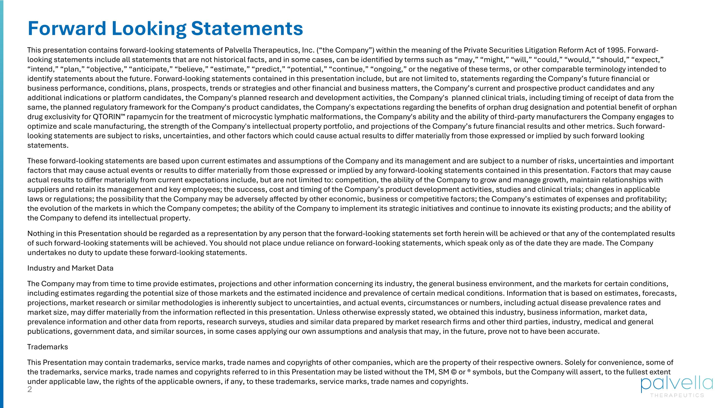
Forward Looking Statements This presentation contains forward-looking statements of Palvella Therapeutics, Inc. (“the Company”) within the meaning of the Private Securities Litigation Reform Act of 1995. Forward-looking statements include all statements that are not historical facts, and in some cases, can be identified by terms such as “may,” “might,” “will,” “could,” “would,” “should,” “expect,” “intend,” “plan,” “objective,” “anticipate,” “believe,” “estimate,” “predict,” “potential,” “continue,” “ongoing,” or the negative of these terms, or other comparable terminology intended to identify statements about the future. Forward-looking statements contained in this presentation include, but are not limited to, statements regarding the Company’s future financial or business performance, conditions, plans, prospects, trends or strategies and other financial and business matters, the Company’s current and prospective product candidates and any additional indications or platform candidates, the Company's planned research and development activities, the Company's planned clinical trials, including timing of receipt of data from the same, the planned regulatory framework for the Company's product candidates, the Company's expectations regarding the benefits of orphan drug designation and potential benefit of orphan drug exclusivity for QTORIN rapamycin for the treatment of microcystic lymphatic malformations, the Company's ability and the ability of third-party manufacturers the Company engages to optimize and scale manufacturing, the strength of the Company's intellectual property portfolio, and projections of the Company’s future ﬁnancial results and other metrics. Such forward-looking statements are subject to risks, uncertainties, and other factors which could cause actual results to differ materially from those expressed or implied by such forward looking statements. These forward-looking statements are based upon current estimates and assumptions of the Company and its management and are subject to a number of risks, uncertainties and important factors that may cause actual events or results to differ materially from those expressed or implied by any forward-looking statements contained in this presentation. Factors that may cause actual results to differ materially from current expectations include, but are not limited to: competition, the ability of the Company to grow and manage growth, maintain relationships with suppliers and retain its management and key employees; the success, cost and timing of the Company’s product development activities, studies and clinical trials; changes in applicable laws or regulations; the possibility that the Company may be adversely affected by other economic, business or competitive factors; the Company’s estimates of expenses and proﬁtability; the evolution of the markets in which the Company competes; the ability of the Company to implement its strategic initiatives and continue to innovate its existing products; and the ability of the Company to defend its intellectual property. Nothing in this Presentation should be regarded as a representation by any person that the forward-looking statements set forth herein will be achieved or that any of the contemplated results of such forward-looking statements will be achieved. You should not place undue reliance on forward-looking statements, which speak only as of the date they are made. The Company undertakes no duty to update these forward-looking statements. Industry and Market Data The Company may from time to time provide estimates, projections and other information concerning its industry, the general business environment, and the markets for certain conditions, including estimates regarding the potential size of those markets and the estimated incidence and prevalence of certain medical conditions. Information that is based on estimates, forecasts, projections, market research or similar methodologies is inherently subject to uncertainties, and actual events, circumstances or numbers, including actual disease prevalence rates and market size, may differ materially from the information reflected in this presentation. Unless otherwise expressly stated, we obtained this industry, business information, market data, prevalence information and other data from reports, research surveys, studies and similar data prepared by market research firms and other third parties, industry, medical and general publications, government data, and similar sources, in some cases applying our own assumptions and analysis that may, in the future, prove not to have been accurate. Trademarks This Presentation may contain trademarks, service marks, trade names and copyrights of other companies, which are the property of their respective owners. Solely for convenience, some of the trademarks, service marks, trade names and copyrights referred to in this Presentation may be listed without the TM, SM © or ® symbols, but the Company will assert, to the fullest extent under applicable law, the rights of the applicable owners, if any, to these trademarks, service marks, trade names and copyrights.

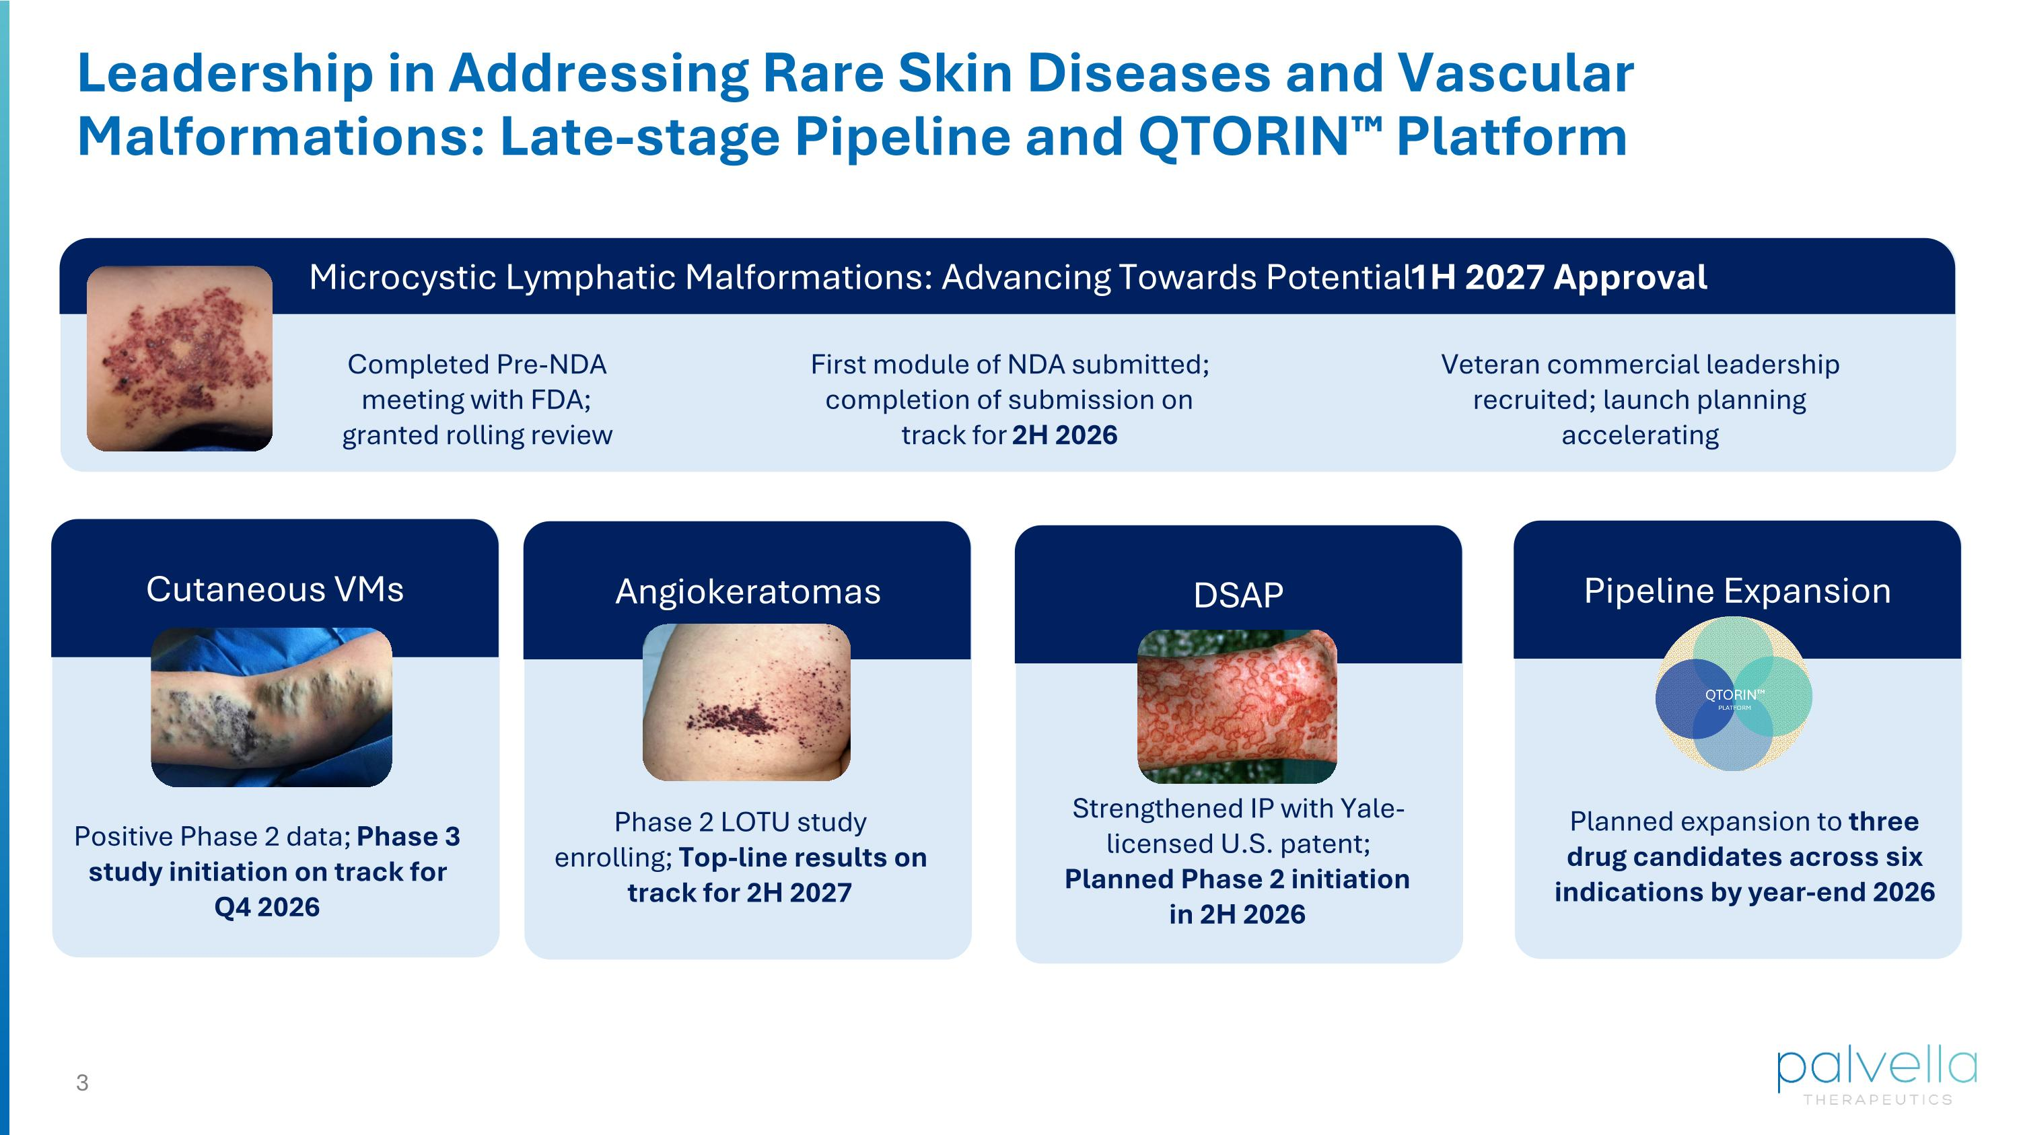
Leadership in Addressing Rare Skin Diseases and Vascular Malformations: Late-stage Pipeline and QTORIN Platform Completed Pre-NDA meeting with FDA; granted rolling review Positive Phase 2 data; Phase 3 study initiation on track for Q4 2026 First module of NDA submitted; completion of submission on track for 2H 2026 Veteran commercial leadership recruited; launch planning accelerating Microcystic Lymphatic Malformations: Advancing Towards Potential 1H 2027 Approval Cutaneous VMs DSAP Phase 2 LOTU study enrolling; Top-line results on track for 2H 2027 Angiokeratomas DSAP Strengthened IP with Yale-licensed U.S. patent; Planned Phase 2 initiation in 2H 2026 DSAP DSAP Planned expansion to three drug candidates across six indications by year-end 2026 Pipeline Expansion

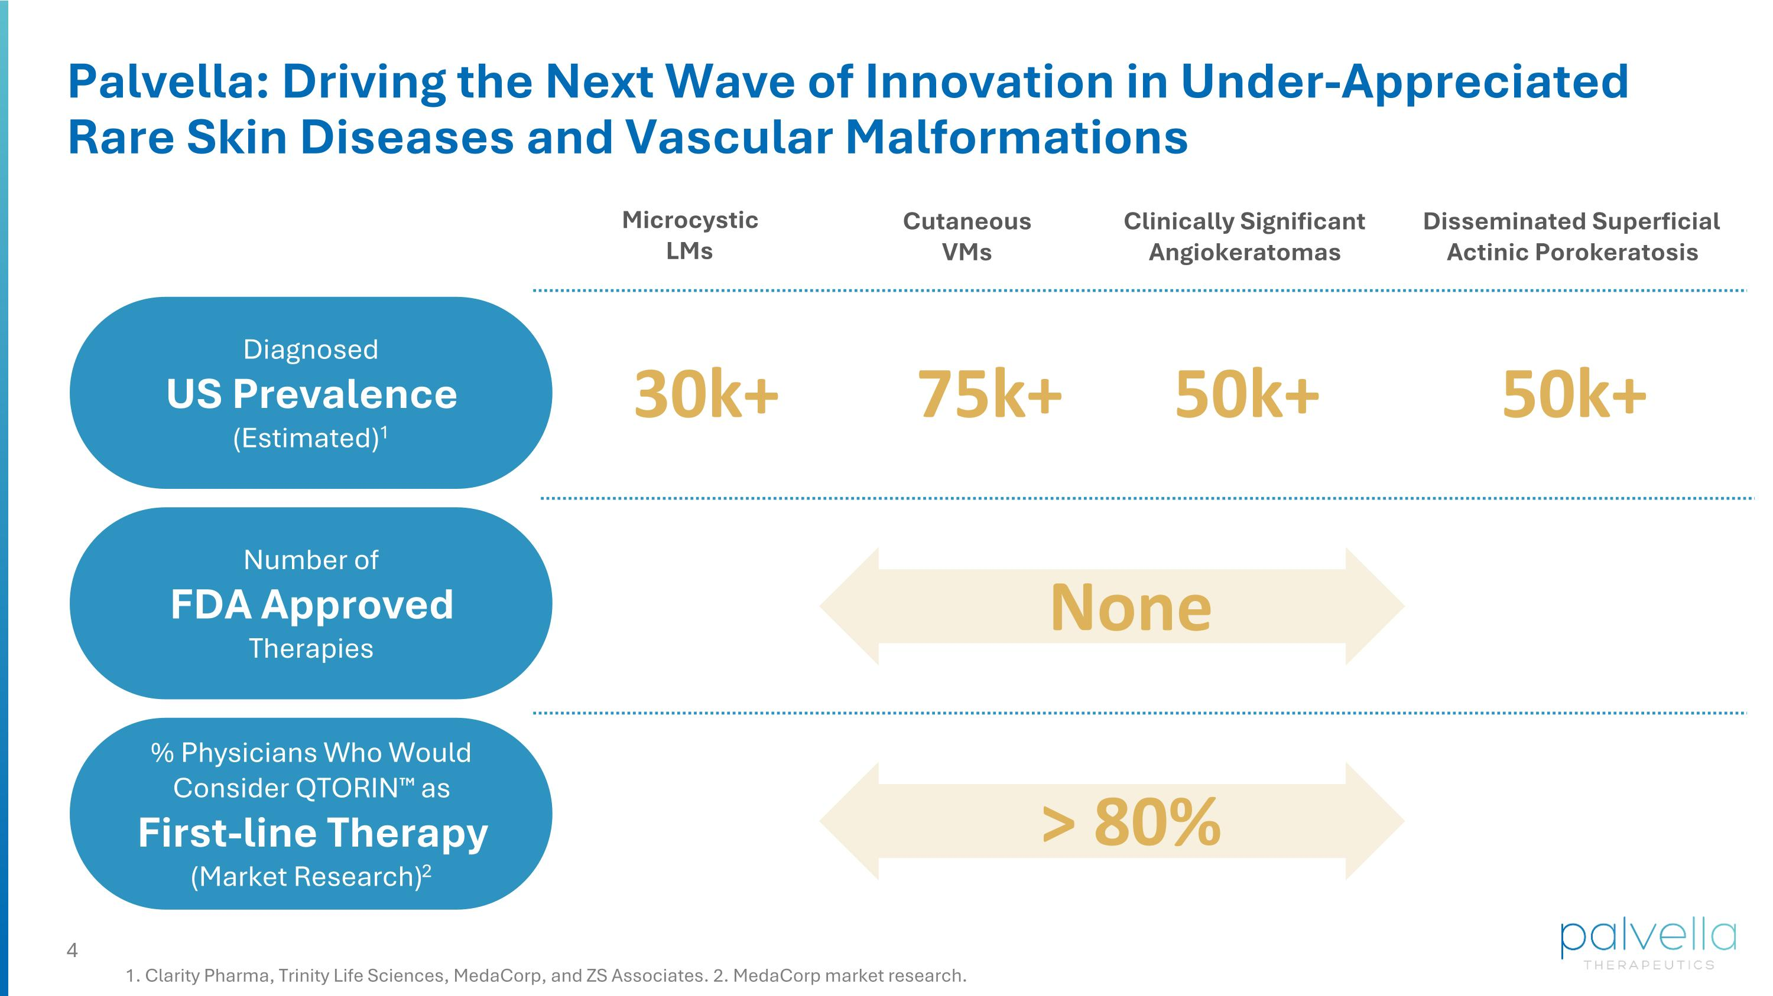
Palvella: Driving the Next Wave of Innovation in Under-Appreciated Rare Skin Diseases and Vascular Malformations 1. Clarity Pharma, Trinity Life Sciences, MedaCorp, and ZS Associates. 2. MedaCorp market research. Diagnosed US Prevalence (Estimated)1 Number of FDA Approved Therapies % Physicians Who Would Consider QTORIN as First-line Therapy (Market Research)2 30k+ Microcystic LMs 75k+ Cutaneous VMs 50k+ Clinically Significant Angiokeratomas 50k+ Disseminated Superficial Actinic Porokeratosis None > 80%

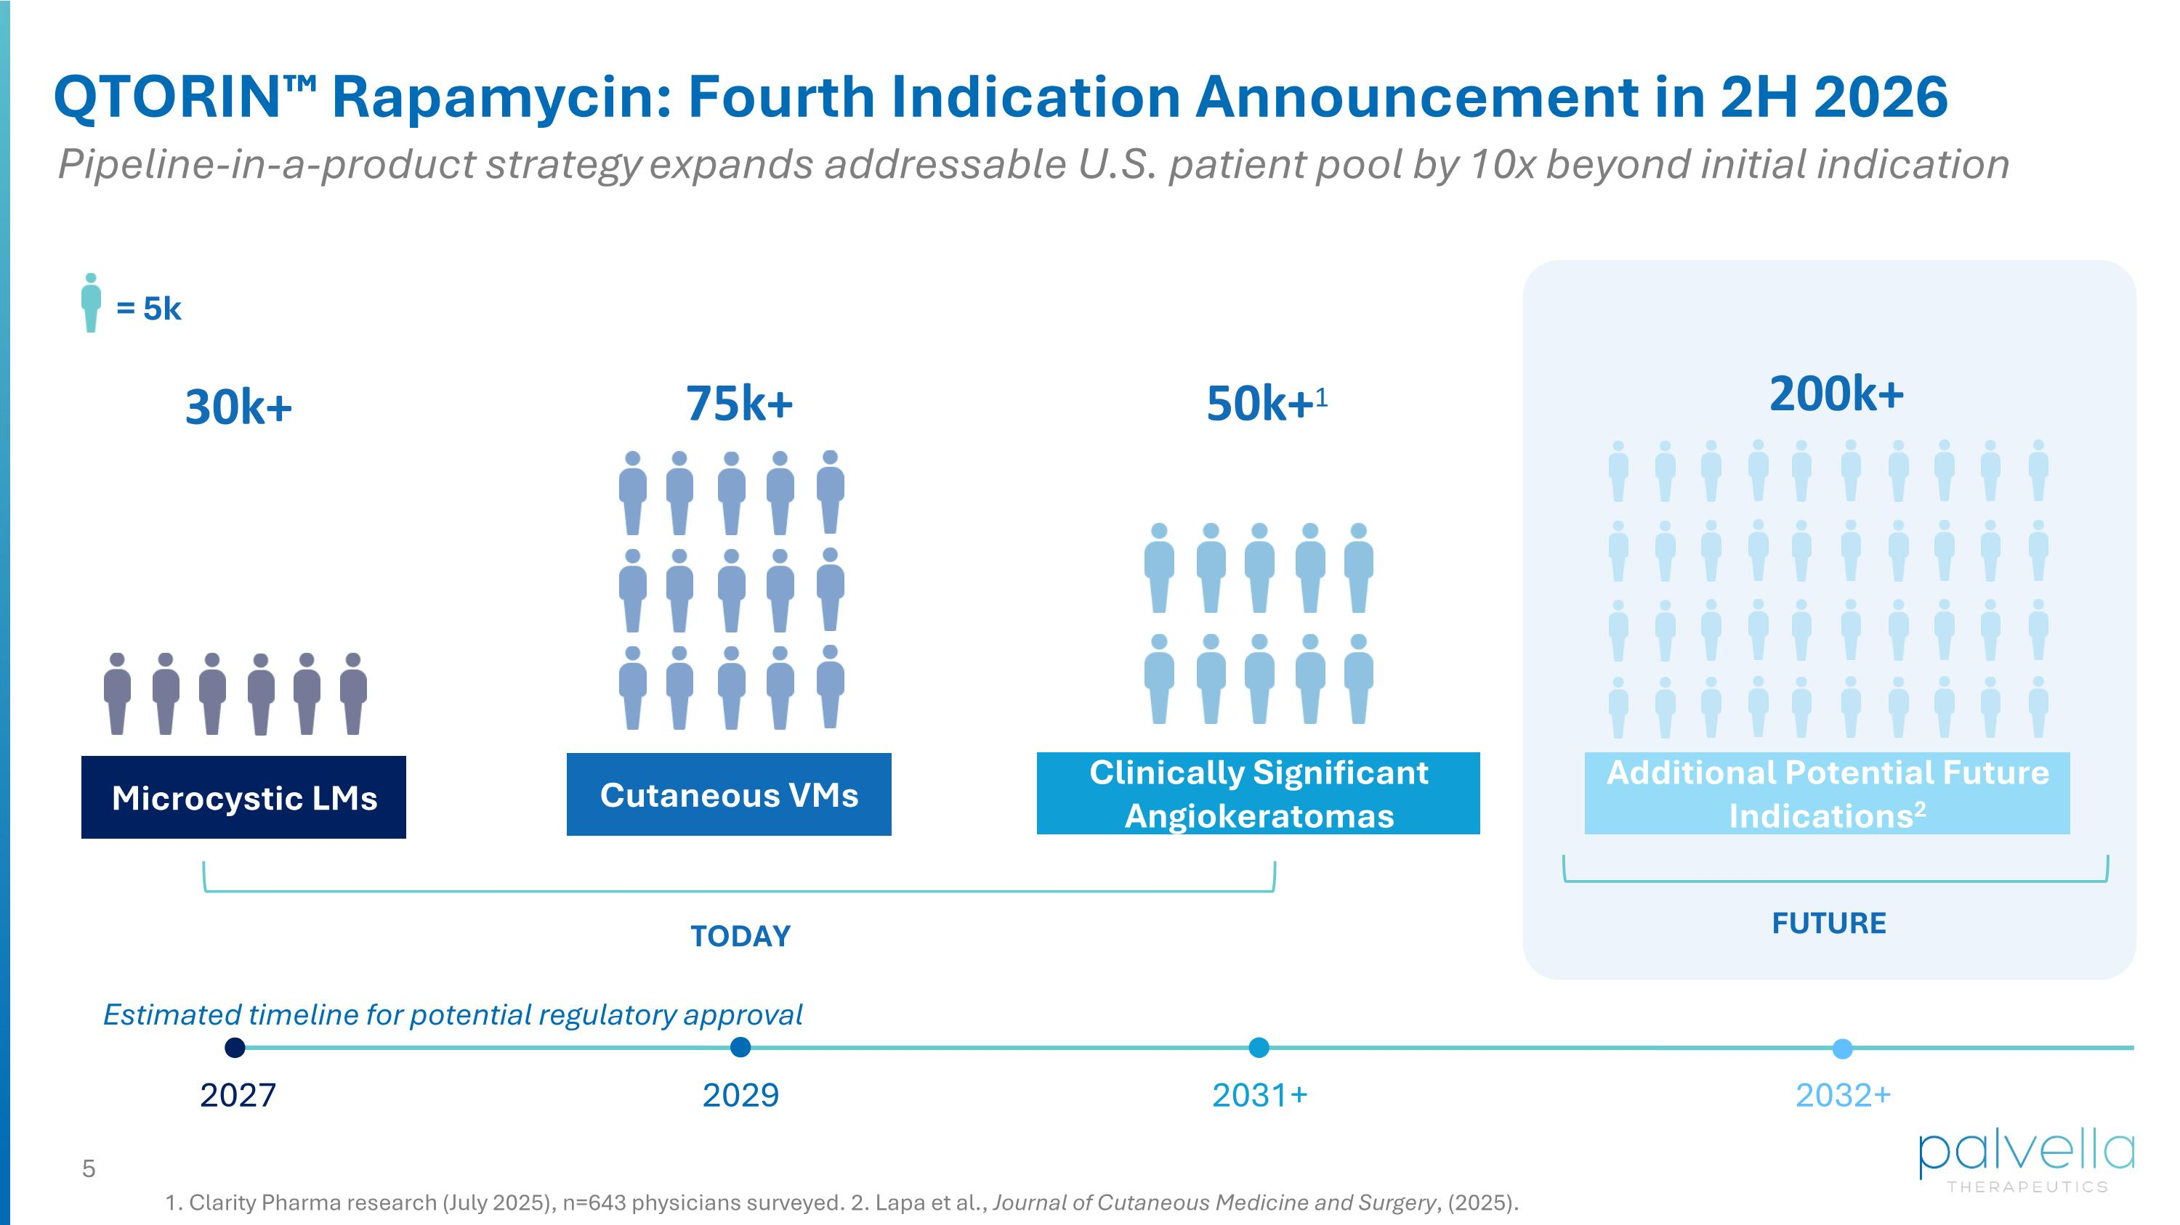
Microcystic LMs Cutaneous VMs Clinically Significant Angiokeratomas Additional Potential Future Indications2 TODAY FUTURE = 5k 30k+ 75k+ 200k+ 50k+1 QTORIN Rapamycin: Fourth Indication Announcement in 2H 2026 1. Clarity Pharma research (July 2025), n=643 physicians surveyed. 2. Lapa et al., Journal of Cutaneous Medicine and Surgery, (2025). Pipeline-in-a-product strategy​ expands addressable U.S. patient pool by 10x beyond initial indication Estimated timeline for potential regulatory approval 2031+ 2032+ 2027 2029

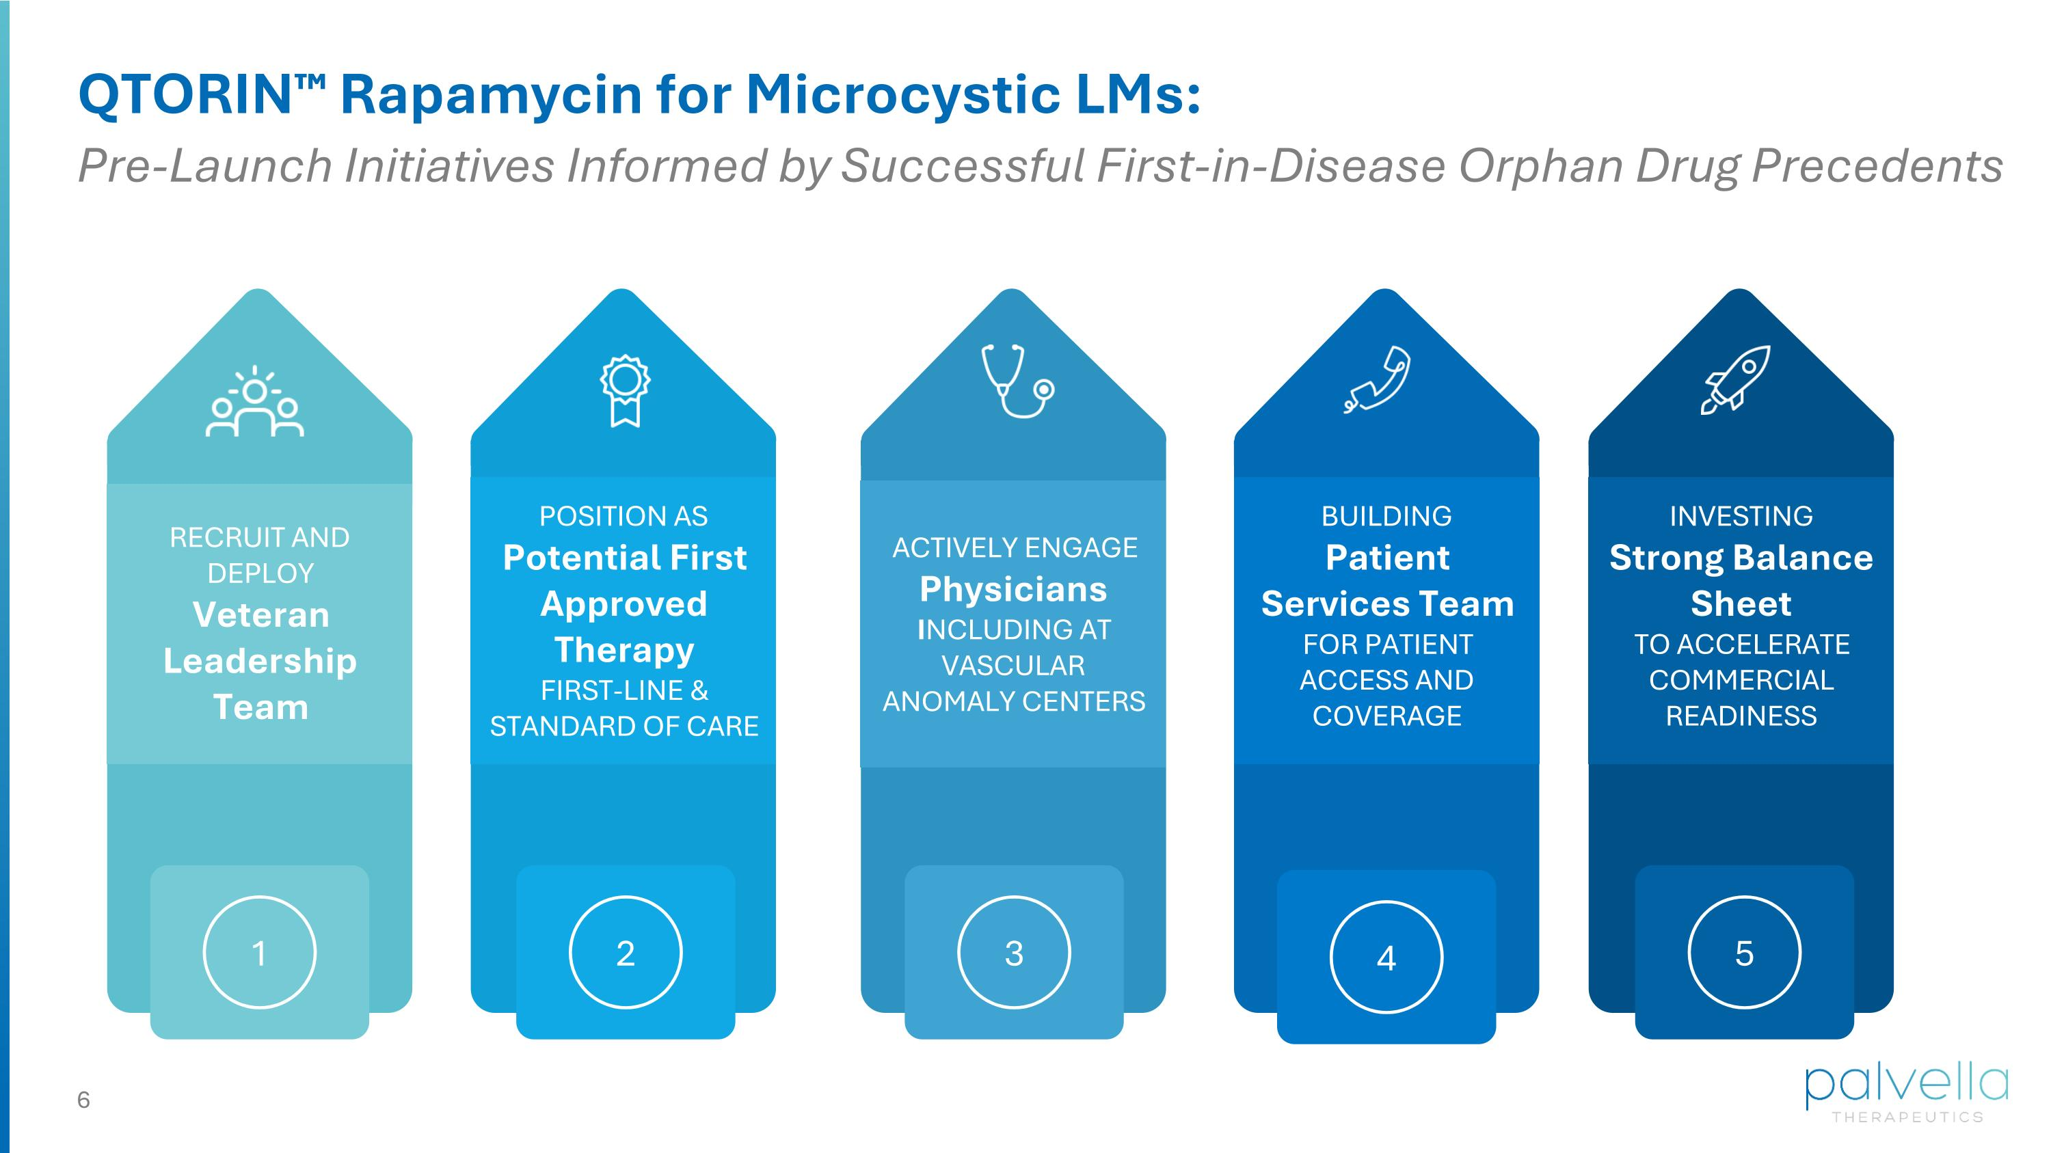
QTORIN Rapamycin for Microcystic LMs: 1 1 2 2 2 3 2 4 2 5 RECRUIT AND DEPLOY Veteran Leadership Team POSITION AS Potential First Approved Therapy FIRST-LINE & STANDARD OF CARE ACTIVELY ENGAGE Physicians INCLUDING AT VASCULAR ANOMALY CENTERS BUILDING Patient Services Team FOR PATIENT ACCESS AND COVERAGE INVESTING Strong Balance Sheet TO ACCELERATE COMMERCIAL READINESS Pre-Launch Initiatives Informed by Successful First-in-Disease Orphan Drug Precedents

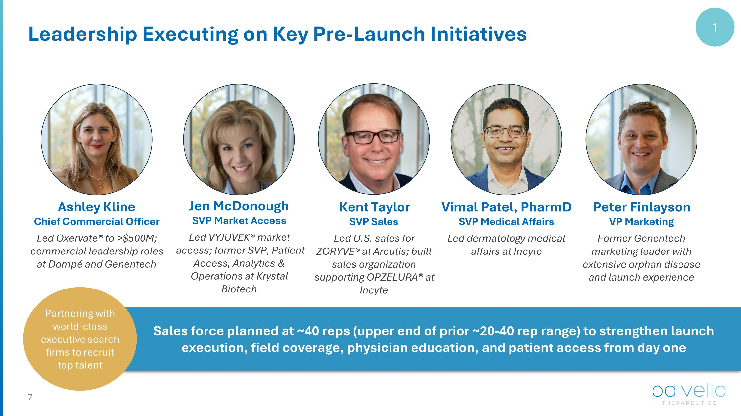
Leadership Executing on Key Pre-Launch Initiatives Ashley Kline Chief Commercial Officer Led Oxervate® to >$500M; commercial leadership roles at Dompé and Genentech Jen McDonough SVP Market Access Led VYJUVEK® market access; former SVP, Patient Access, Analytics & Operations at Krystal Biotech Vimal Patel, PharmD SVP Medical Affairs Led dermatology medical affairs at Incyte Sales force planned at ~40 reps (upper end of prior ~20-40 rep range) to strengthen launch execution, field coverage, physician education, and patient access from day one Partnering with world-class executive search firms to recruit top talent 1 Peter Finlayson VP Marketing Former Genentech marketing leader with extensive orphan disease and launch experience Kent Taylor SVP Sales Led U.S. sales for ZORYVE® at Arcutis; built sales organization supporting OPZELURA® at Incyte

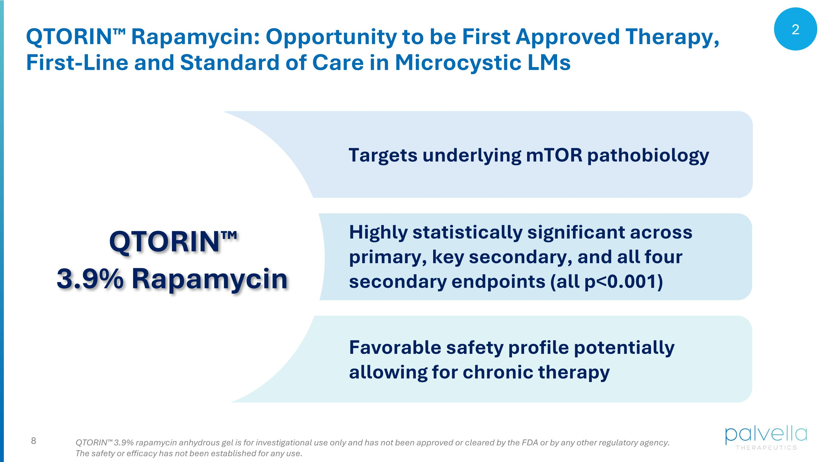
QTORIN Rapamycin: Opportunity to be First Approved Therapy, First-Line and Standard of Care in Microcystic LMs Targets underlying mTOR pathobiology QTORIN 3.9% rapamycin anhydrous gel is for investigational use only and has not been approved or cleared by the FDA or by any other regulatory agency. The safety or efficacy has not been established for any use. Highly statistically significant across primary, key secondary, and all four secondary endpoints (all p<0.001) Favorable safety profile potentially allowing for chronic therapy QTORIN 3.9% Rapamycin 2

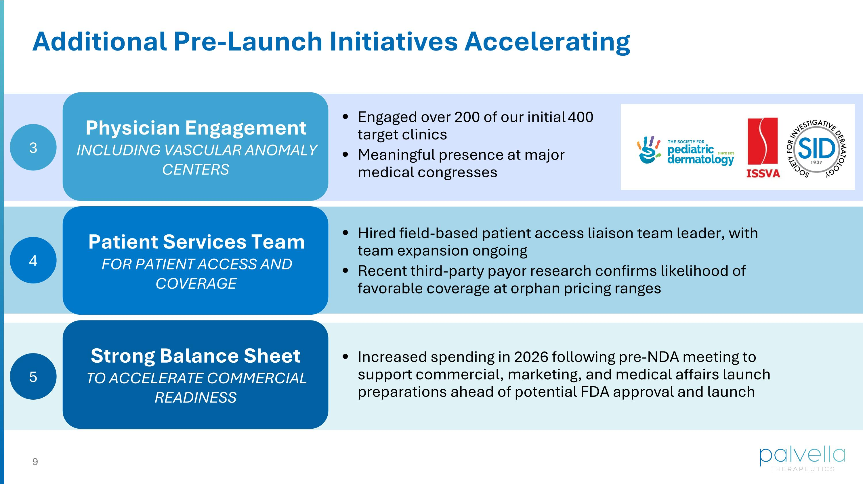
Engaged over 200 of our initial 400 target clinics Meaningful presence at major ?medical congresses Additional Pre-Launch Initiatives Accelerating Physician Engagement INCLUDING VASCULAR ANOMALY CENTERS Hired field-based patient access liaison team leader, with team expansion ongoing Recent third-party payor research confirms likelihood of favorable coverage at orphan pricing ranges Patient Services Team FOR PATIENT ACCESS AND COVERAGE Increased spending in 2026 following pre-NDA meeting to support commercial, marketing, and medical affairs launch preparations ahead of potential FDA approval and launch Strong Balance Sheet TO ACCELERATE COMMERCIAL READINESS 3 4 5

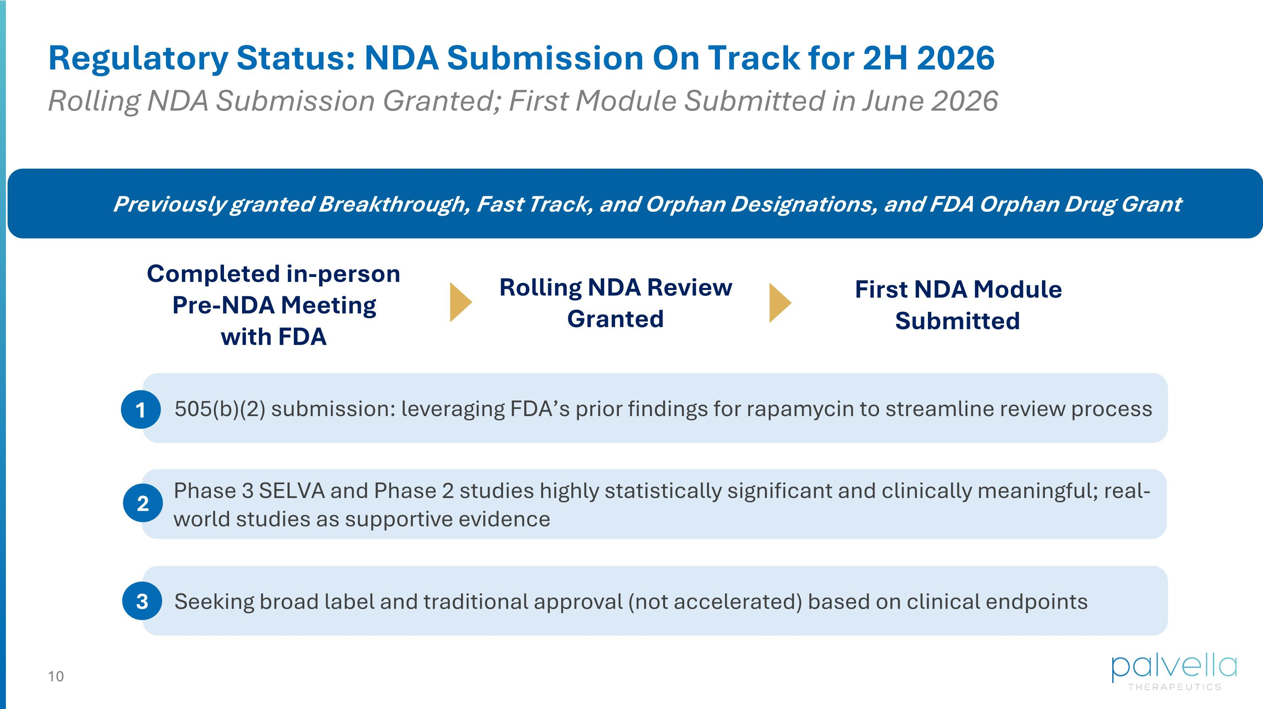
Phase 3 SELVA and Phase 2 studies highly statistically significant and clinically meaningful; real-world studies as supportive evidence 2 Previously granted Breakthrough, Fast Track, and Orphan Designations, and FDA Orphan Drug Grant 505(b)(2) submission: leveraging FDA’s prior findings for rapamycin to streamline review process 1 Seeking broad label and traditional approval (not accelerated) based on clinical endpoints 3 Regulatory Status: NDA Submission On Track for 2H 2026 Rolling NDA Submission Granted; First Module Submitted in June 2026 Completed in-person Pre-NDA Meeting with FDA Rolling NDA Review ?Granted First NDA Module ?Submitted


Rare Disease Pipeline Updates

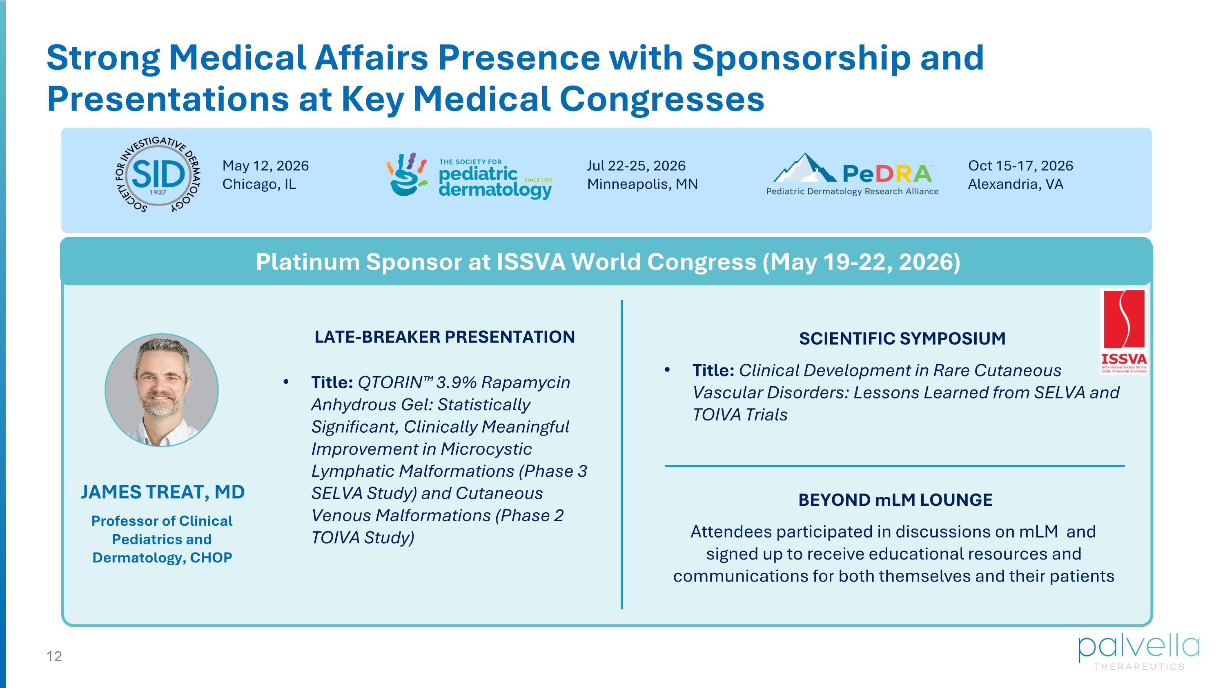
Strong Medical Affairs Presence with Sponsorship and Presentations at Key Medical Congresses Platinum Sponsor at ISSVA World Congress (May 19-22, 2026) Title: QTORIN 3.9% Rapamycin Anhydrous Gel: Statistically Significant, Clinically Meaningful Improvement in Microcystic Lymphatic Malformations (Phase 3 SELVA Study) and Cutaneous Venous Malformations (Phase 2 TOIVA Study) LATE-BREAKER PRESENTATION SCIENTIFIC SYMPOSIUM Title: Clinical Development in Rare Cutaneous Vascular Disorders: Lessons Learned from SELVA and TOIVA Trials BEYOND mLM LOUNGE Attendees can participate in discussions on mLM and sign up to receive educational resources and communications for both themselves and their patients JAMES TREAT, MD Professor of Clinical Pediatrics and Dermatology, CHOP May 12, 2026 Chicago, IL Jul 22-25, 2026?Minneapolis, MN Oct 15-17, 2026 Alexandria, VA Attendees participated in discussions on mLM and signed up to receive educational resources and communications for both themselves and their patients

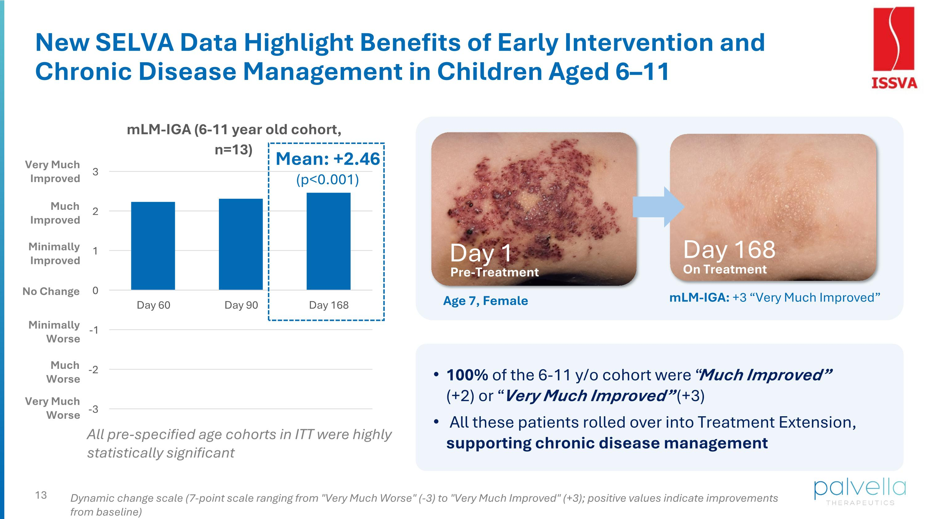
All pre-specified age cohorts in ITT were highly statistically significant New SELVA Data Highlight Benefits of Early Intervention and Chronic Disease Management in Children Aged 6–11 Pre-Treatment On Treatment Day 1 Day 168 mLM-IGA: +3 “Very Much Improved” Age 7, Female Mean: +2.46 (p<0.001) Very Much Improved Very Much Worse Much Improved Minimally Improved No Change Much Worse Minimally Worse 100% of the 6-11 y/o cohort were “Much Improved” (+2) or “Very Much Improved” (+3) All these patients rolled over into Treatment Extension, supporting chronic disease management Dynamic change scale (7-point scale ranging from "Very Much Worse" (-3) to "Very Much Improved" (+3); positive values indicate improvements from baseline)

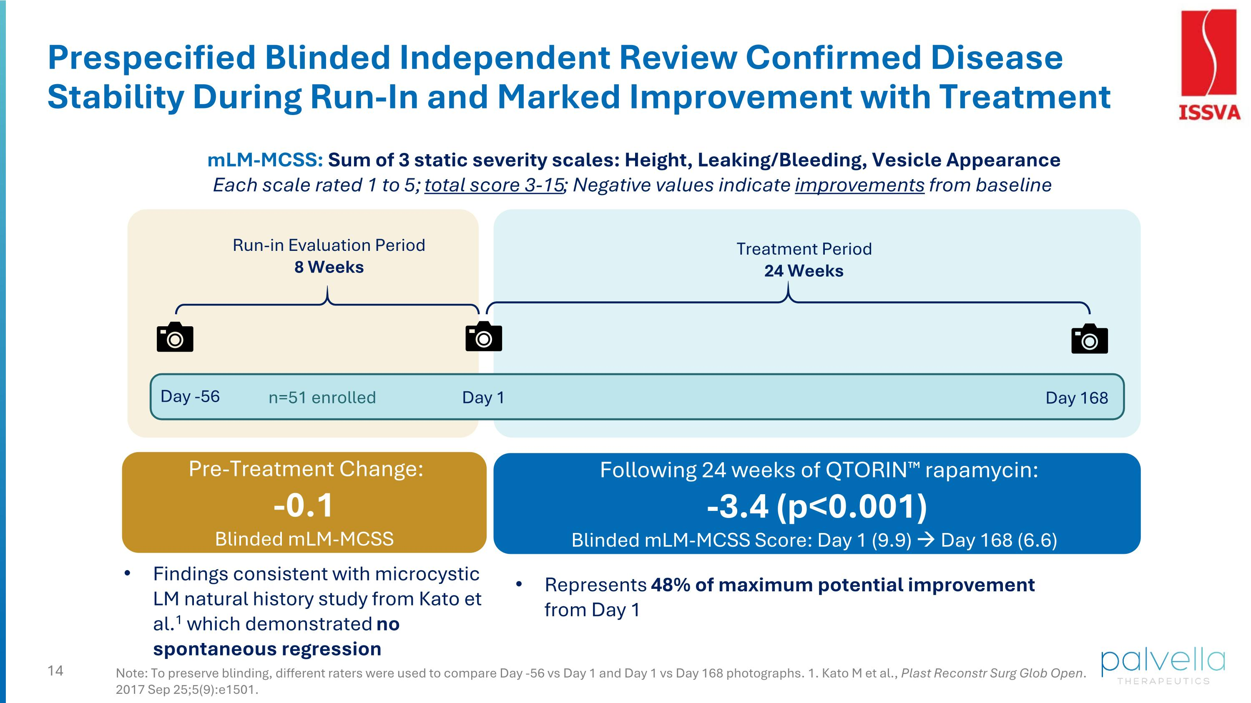
Run-in Evaluation Period 8 Weeks Prespecified Blinded Independent Review Confirmed Disease Stability During Run-In and Marked Improvement with Treatment Note: To preserve blinding, different raters were used to compare Day -56 vs Day 1 and Day 1 vs Day 168 photographs. 1. Kato M et al., Plast Reconstr Surg Glob Open. 2017 Sep 25;5(9):e1501. Day -56 Day 1 mLM-MCSS: Sum of 3 static severity scales: Height, Leaking/Bleeding, Vesicle Appearance Each scale rated 1 to 5; total score 3-15; Negative values indicate improvements from baseline n=51 enrolled Day 168 Treatment Period 24 Weeks Findings consistent with microcystic LM natural history study from Kato et al.1 which demonstrated no spontaneous regression Pre-Treatment Change: -0.1 Blinded mLM-MCSS Following 24 weeks of QTORIN rapamycin: -3.4 (p<0.001) Blinded mLM-MCSS Score: Day 1 (9.9) → Day 168 (6.6) Represents 48% of maximum potential improvement from Day 1

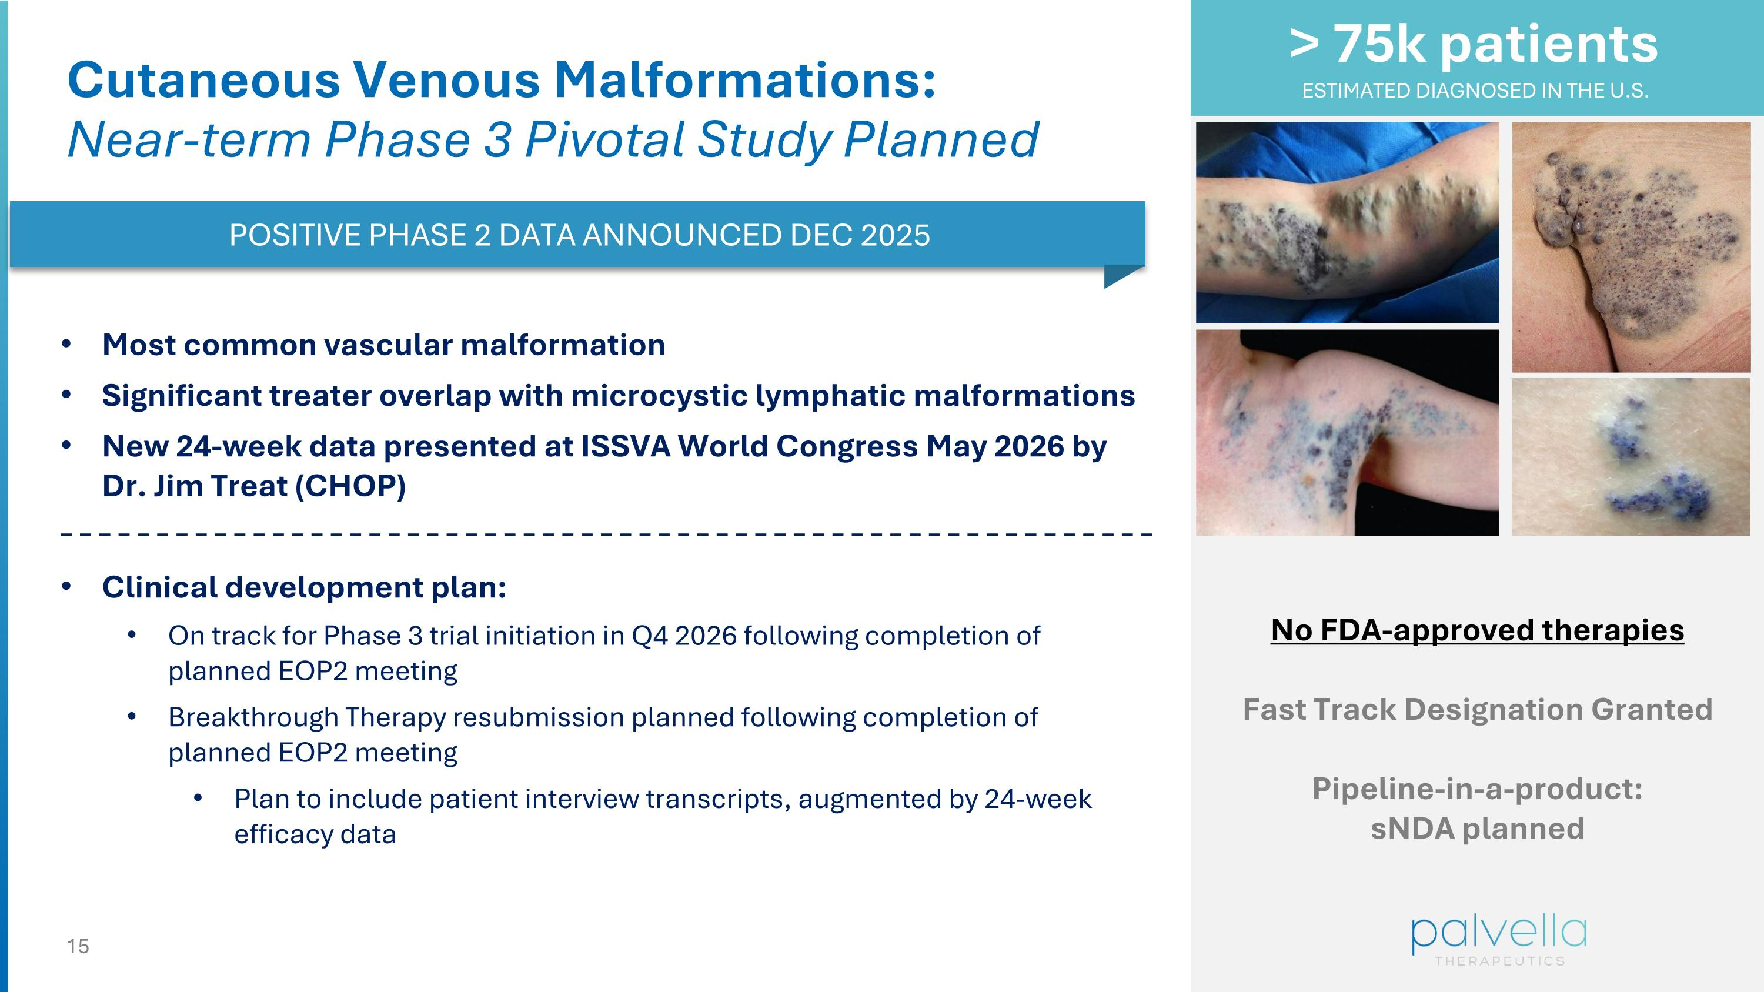
Cutaneous Venous Malformations:?Near-term Phase 3 Pivotal Study Planned No FDA-approved therapies Fast Track Designation Granted Pipeline-in-a-product: sNDA planned > 75k patients ESTIMATED DIAGNOSED IN THE U.S. POSITIVE PHASE 2 DATA ANNOUNCED DEC 2025 Most common vascular malformation Significant treater overlap with microcystic lymphatic malformations New 24-week data presented at ISSVA World Congress May 2026 by Dr. Jim Treat (CHOP) Clinical development plan: On track for Phase 3 trial initiation in Q4 2026 following completion of planned EOP2 meeting Breakthrough Therapy resubmission planned following completion of planned EOP2 meeting Plan to include patient interview transcripts, augmented by 24-week efficacy data

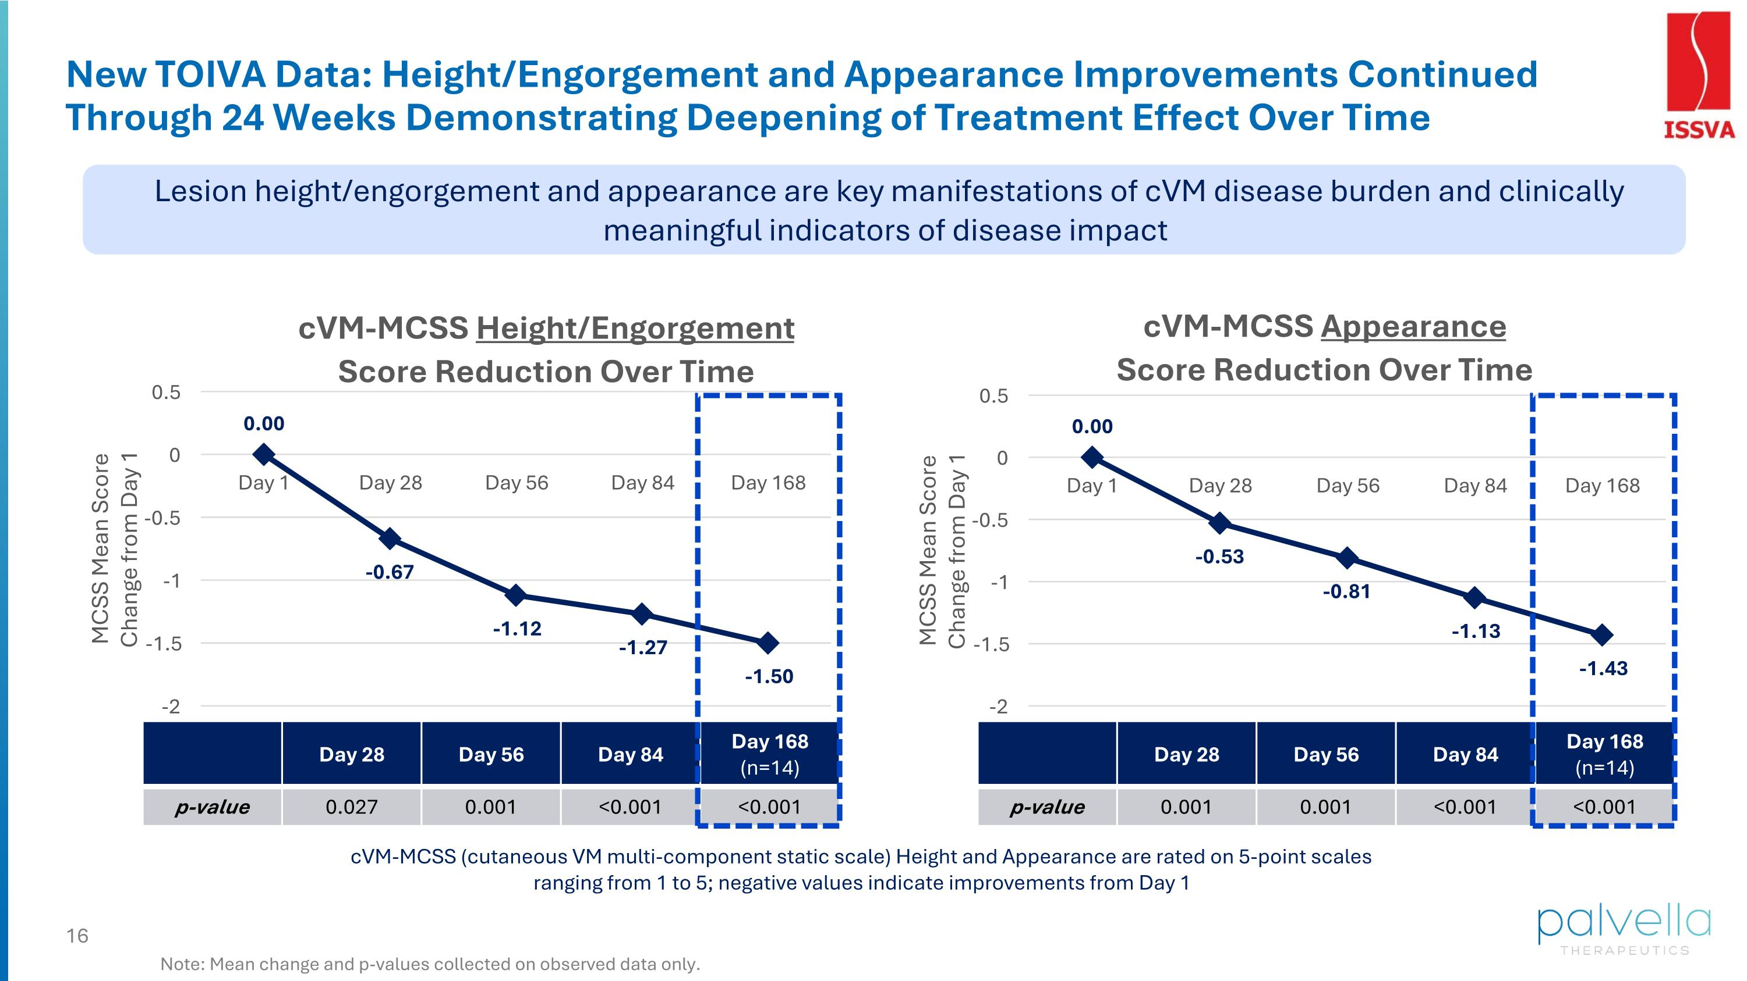
Day 28 Day 56 Day 84 Day 168 (n=14) p-value 0.001 0.001 <0.001 <0.001 New TOIVA Data: Height/Engorgement and Appearance Improvements Continued Through 24 Weeks Demonstrating Deepening of Treatment Effect Over Time Day 28 Day 56 Day 84 Day 168 (n=14) p-value 0.027 0.001 <0.001 <0.001 Note: Mean change and p-values collected on observed data only. cVM-MCSS (cutaneous VM multi-component static scale) Height and Appearance are rated on 5-point scales ranging from 1 to 5; negative values indicate improvements from Day 1 Lesion height/engorgement and appearance are key manifestations of cVM disease burden and clinically meaningful indicators of disease impact

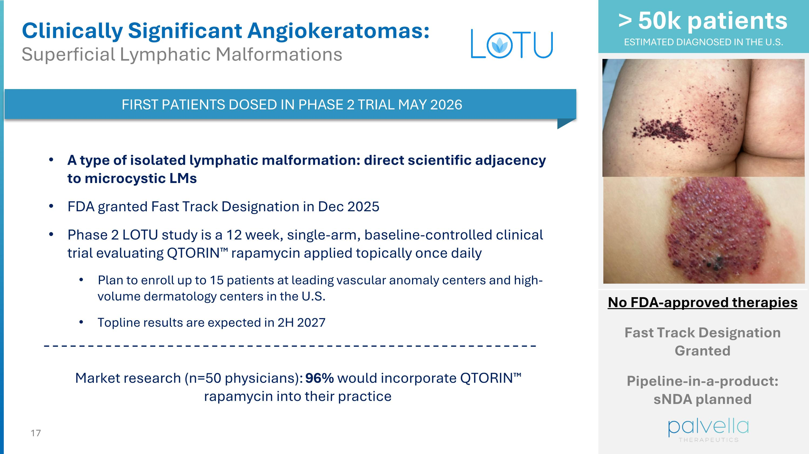
> 50k patients ESTIMATED DIAGNOSED IN THE U.S. Clinically Significant Angiokeratomas: ?Superficial Lymphatic Malformations FIRST PATIENTS DOSED IN PHASE 2 TRIAL MAY 2026 A type of isolated lymphatic malformation: direct scientific adjacency to microcystic LMs FDA granted Fast Track Designation in Dec 2025 Phase 2 LOTU study is a 12 week, single-arm, baseline-controlled clinical trial evaluating QTORIN rapamycin applied topically once daily Plan to enroll up to 15 patients at leading vascular anomaly centers and high-volume dermatology centers in the U.S. Topline results are expected in 2H 2027 Market research (n=50 physicians): 96% would incorporate QTORIN rapamycin into their practice No FDA-approved therapies Fast Track Designation Granted Pipeline-in-a-product: sNDA planned

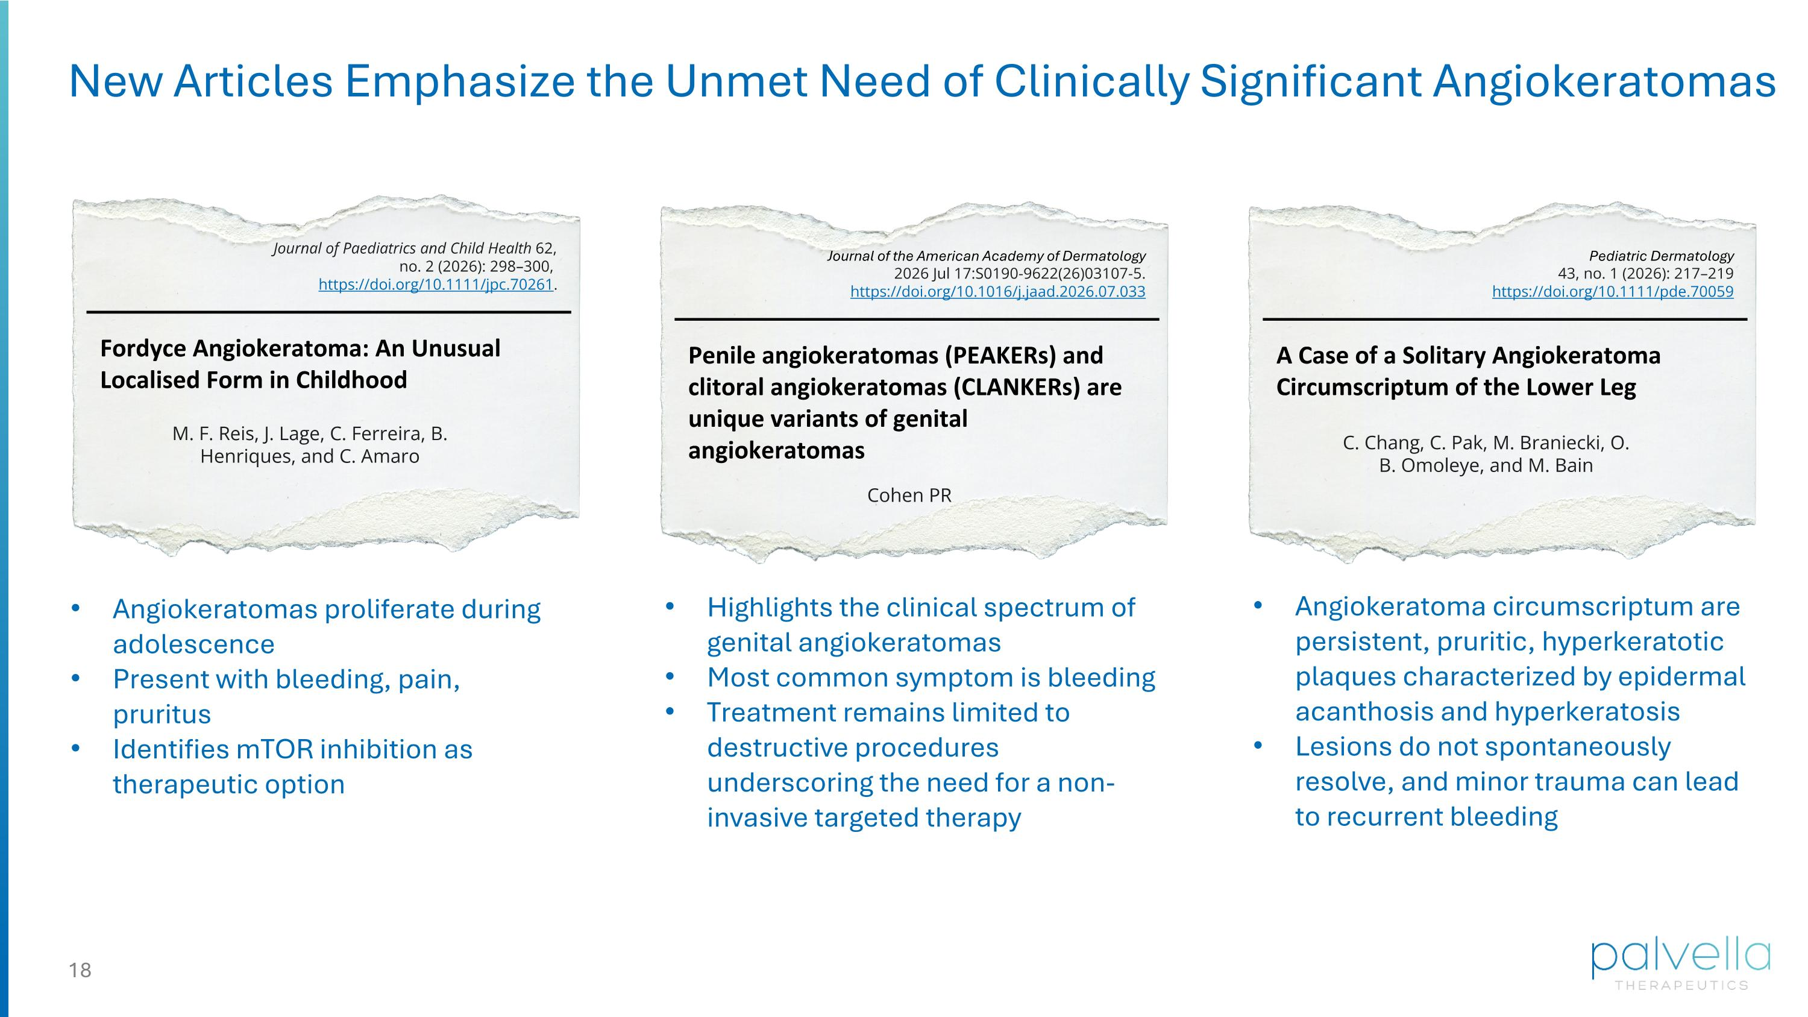
New Articles Emphasize the Unmet Need of Clinically Significant Angiokeratomas Fordyce Angiokeratoma: An Unusual Localised Form in Childhood M. F. Reis, J. Lage, C. Ferreira, B. Henriques, and C. Amaro Journal of Paediatrics and Child Health 62, no. 2 (2026): 298–300, https://doi.org/10.1111/jpc.70261. Angiokeratomas proliferate during adolescence Present with bleeding, pain, pruritus Identifies mTOR inhibition as therapeutic option Penile angiokeratomas (PEAKERs) and clitoral angiokeratomas (CLANKERs) are unique variants of genital angiokeratomas Cohen PR Journal of the American Academy of Dermatology 2026 Jul 17:S0190-9622(26)03107-5. https://doi.org/10.1016/j.jaad.2026.07.033 Highlights the clinical spectrum of genital angiokeratomas Most common symptom is bleeding Treatment remains limited to destructive procedures underscoring the need for a non-invasive targeted therapy A Case of a Solitary Angiokeratoma Circumscriptum of the Lower Leg C. Chang, C. Pak, M. Braniecki, O. B. Omoleye, and M. Bain Pediatric Dermatology 43, no. 1 (2026): 217–219 https://doi.org/10.1111/pde.70059 Angiokeratoma circumscriptum are persistent, pruritic, hyperkeratotic plaques characterized by epidermal acanthosis and hyperkeratosis Lesions do not spontaneously resolve, and minor trauma can lead to recurrent bleeding

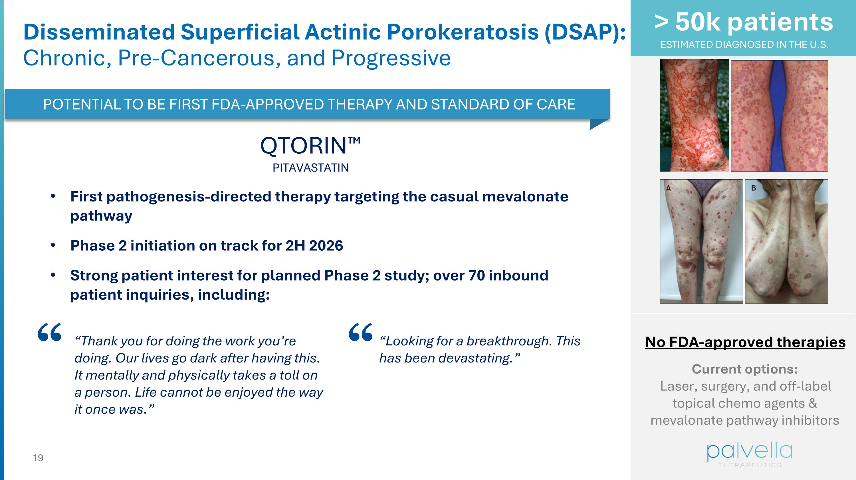
> 50k patients ESTIMATED DIAGNOSED IN THE U.S. Disseminated Superficial Actinic Porokeratosis (DSAP): ?Chronic, Pre-Cancerous, and Progressive No FDA-approved therapies Current options: Laser, surgery, and off-label topical chemo agents & mevalonate pathway inhibitors QTORIN PITAVASTATIN POTENTIAL TO BE FIRST FDA-APPROVED THERAPY AND STANDARD OF CARE First pathogenesis-directed therapy targeting the casual mevalonate pathway Phase 2 initiation on track for 2H 2026 Strong patient interest for planned Phase 2 study; over 70 inbound patient inquiries, including: “Thank you for doing the work you’re doing. Our lives go dark after having this. It mentally and physically takes a toll on a person. Life cannot be enjoyed the way it once was.” “Looking for a breakthrough. This has been devastating.”


Finance & Cash Update

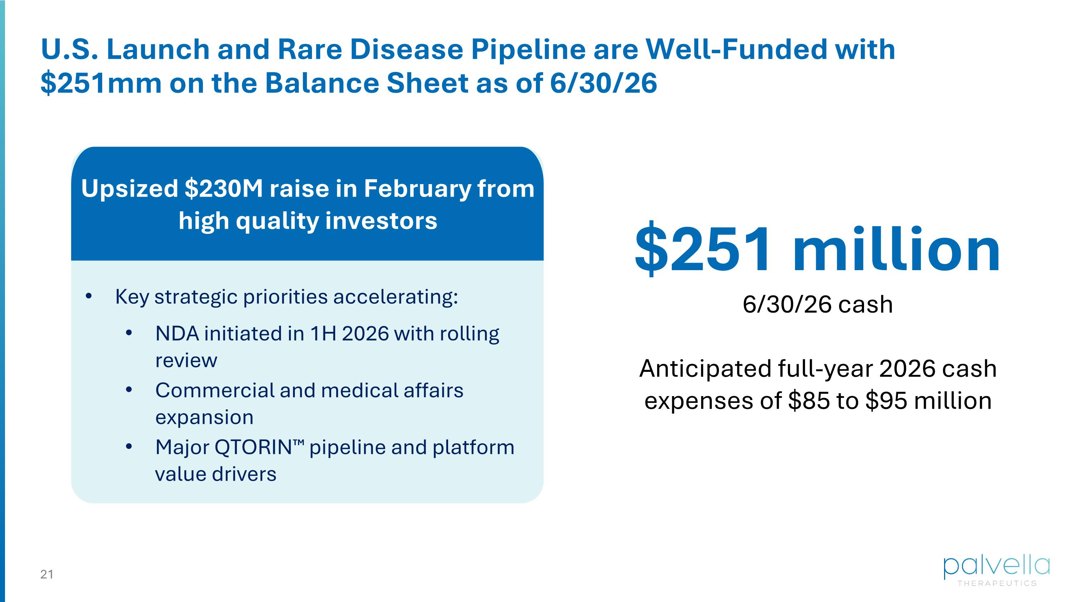
Key strategic priorities accelerating: NDA initiated in 1H 2026 with rolling review Commercial and medical affairs expansion Major QTORIN pipeline and platform value drivers $251 million 6/30/26 cash Anticipated full-year 2026 cash expenses of $85 to $95 million U.S. Launch and Rare Disease Pipeline are Well-Funded with $251mm on the Balance Sheet as of 6/30/26 Upsized $230M raise in February from high quality investors


Closing Remarks

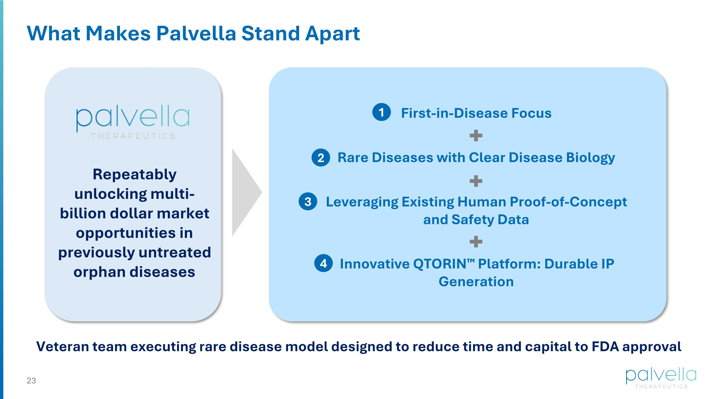
What Makes Palvella Stand Apart Repeatably unlocking multi-billion dollar market opportunities in previously untreated orphan diseases First-in-Disease Focus Rare Diseases with Clear Disease Biology Leveraging Existing Human Proof-of-Concept and Safety Data Innovative QTORIN Platform: Durable IP Generation Veteran team executing rare disease model designed to reduce time and capital to FDA approval 1 2 3 4


Q&A


Striving to be first for rare disease patients Thank You

